guide to getting started

with the European Social Survey
This guide looks at getting started using archived data. The example it uses is of someone preparing to the use the most recent round of the European Social Survey (ESS) to examine the relationship between social values and support for different political parties.

The European social survey
The European Social Survey (ESS), which is a biennial cross-national survey, is a great example of archived data. The archiving, processing and distribution of data and documentation is done by NSD - Norwegian Centre for Research Data but ESS data and documentation can be found on a dedicated website along with many other useful publications and resources.
- Visit the website europeansocialsurvey.org

Locating data and documentation
On the ESS website, there is a section for Data and Documentation that shows the many ways you can explore and access ESS data.
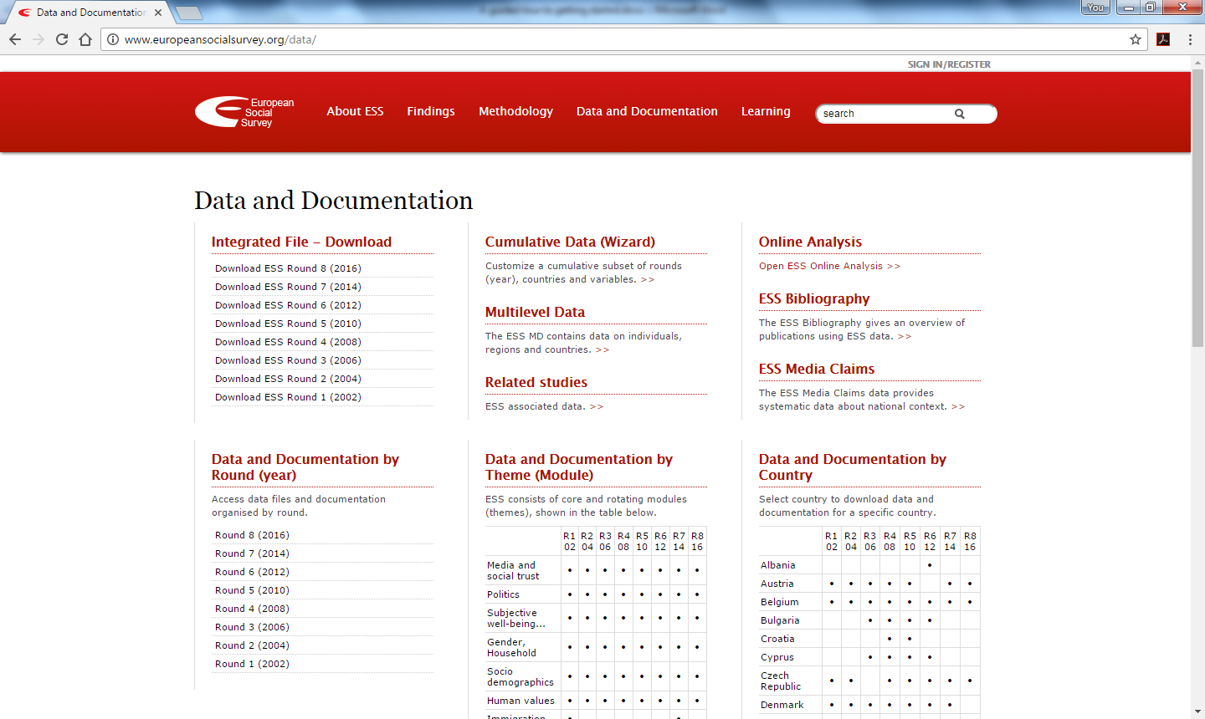

Data and documentation by year – the integrated file
A key way ESS data is distributed is via an Integrated File for each round which includes data from all the countries participating in that round. We know we want to access data and documentation for the most recent round (which is Round 8 at present).
- Clicking on Round 8 (2016) under Data and Documentation by Round (year) takes us to a webpage providing access to both the data and documentation associated with the Round.
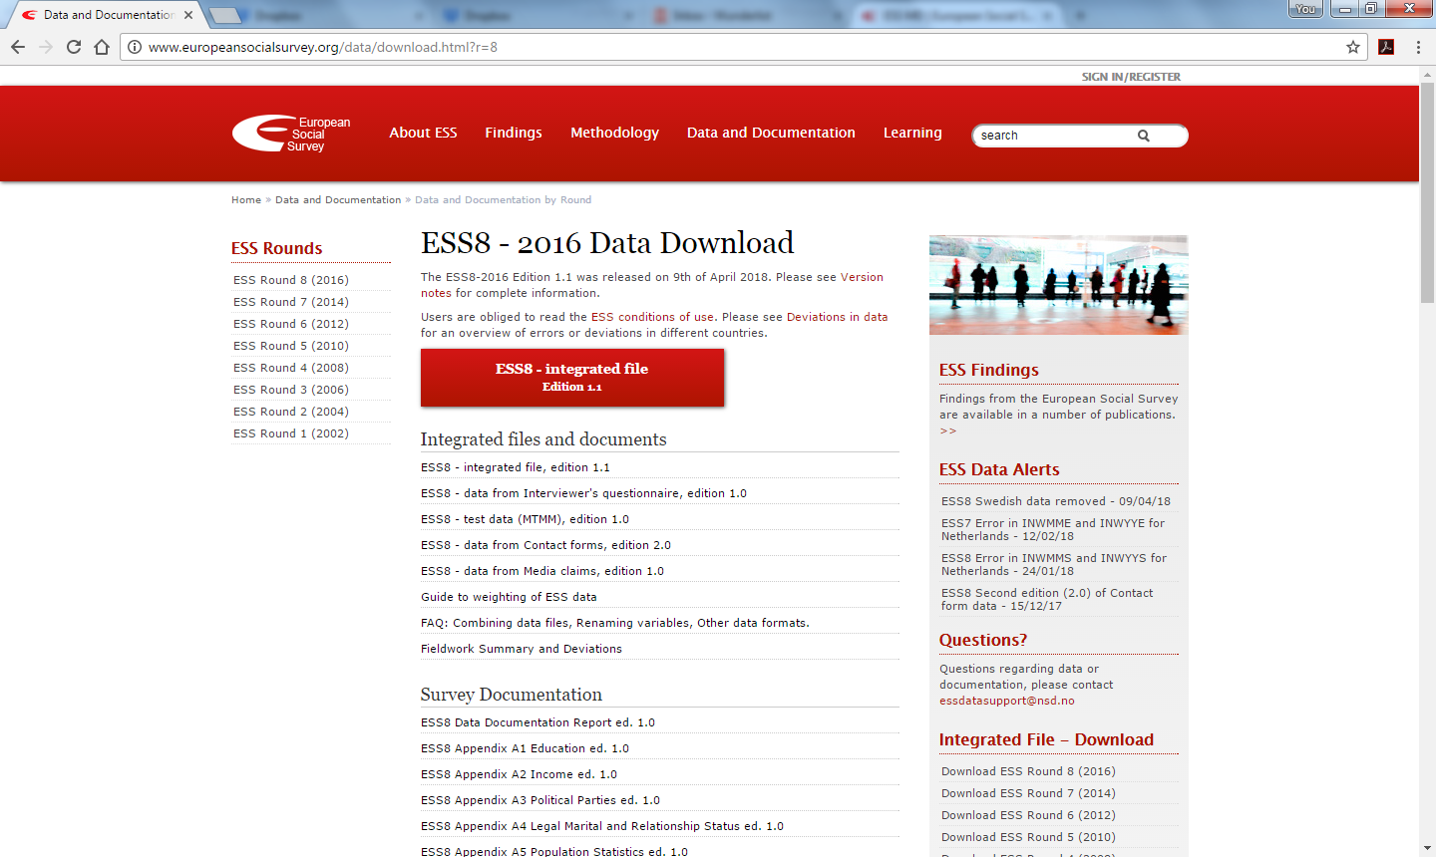

Data Access
You can access the current version of the Integrated file from this page by clicking the red button. The ESS data is available free of charge for non-commercial use after a short registration. Users are also obliged to read and follow the conditions of use (http://www.europeansocialsurvey.org/data/conditions_of_use.html).
You choose to access the data in SAS, SPSS or STATA format.
In addition to the main Integrate File, separate datasets also contain interviewer’s questionnaire data, test variables data, contact forms data, media claims come. Scroll to the bottom and you can also find individual country files for each year can be downloaded.

Versions and version notes
After their initial release, datasets may be amended if new data becomes available or errors in the data are noticed. Information about current version is clear and version notes explain differences across versions.

User guide/study level documentation
Data collections will usually have a core document to accompany and document the data. In the case of the ESS8-2016, there is a Documentation Report. Since the ESS consists of many national surveys the report includes a general study description and country reports. The country reports contain important information on sampling procedures, response rates and other country specific study related materials.

Survey weights
Survey weights are very common with survey data and often a dataset might include more than one weight. You will usually need to check the documentation to understand when and how to use the weighting variables. This form of information is often within the user guide but in the case of the ESS there is a separate document discussing the survey weights.
- Find the guide to Weighting of ESS data in the documentation for the most recent guide.

Variables
A key step to working with survey data is to identify which variables to use. In this example, we are looking for variables relating to social values and support for political parties.

Variable list
A variable list (Appendix 8 in the documentation) can be a useful place to start. Scrolling or searching the list can help you get a feel for the contents of the dataset (e.g. typing ‘party’ highlights variables relating political parties).
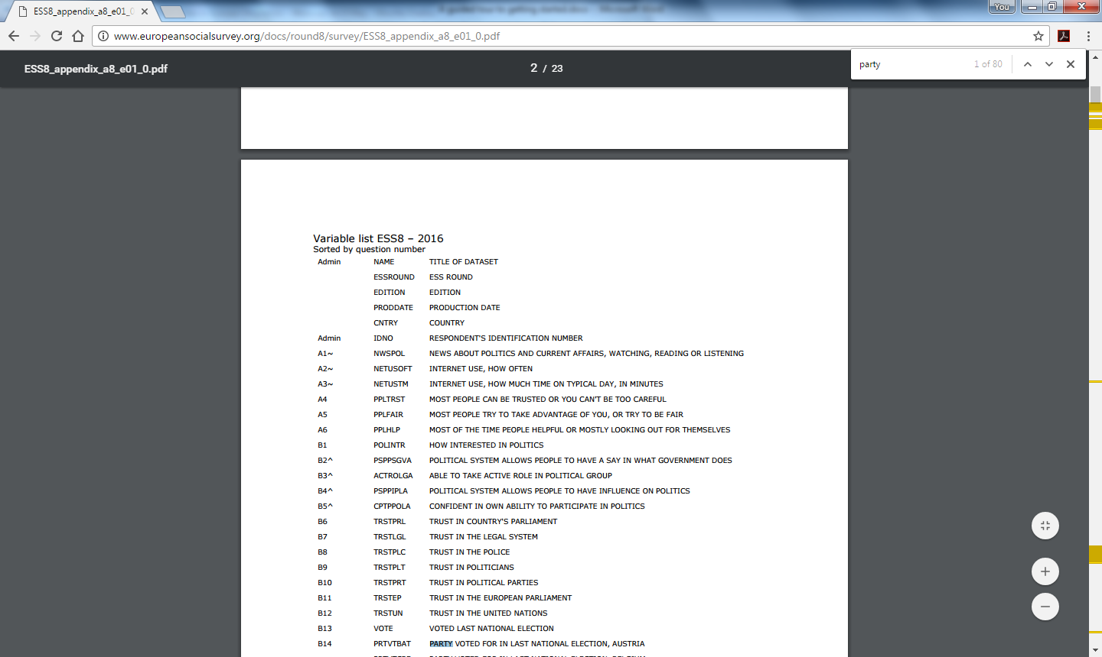

Going back to the underlying questions
The variable list does not include the full question wording. In this case, more detailed information is contained in the document Variable and Questions (Appendix 7) (often there is a copy of the questionnaire). As you can see below for the question ‘Which party did you vote for in that election? (Czech Republic), this document links the question number with the question wording, variable name and label with the different options and their values in the dataset. There is also other information about the values of different forms of non-response and important information about who was asked this question (question routing).

Think about question routing
The questions participants are asked in surveys can depend on how they answered previous questions. In this case under Filter, we can see that this question was only asked to those who gave a positive response (code 1 to the previous question B3). Why does this make sense?
We need to remember the group that the data relates to when examining frequencies – for instance, the proportion who voted KSCM relates to the proportion of those who voted and not the proportion of the sample/population.

Check any notes/comments about variables
Documentation can include important information about variables. For instance, in the picture above a comment is that these are “country-specific codes”.
Though such a comment is quite obvious for a variable about political parties, it is important to consider when analysing data from multiple countries simultaneously. As it stands, a code of 1 in one country is not the same as a code of 1 in another country. Hence, some types of cross-national analysis would require the information from such variables to be transformed into a cross-nationally equivalent measure.

Other DOCUMENTATION ABOUT classifications
A very useful feature of the ESS is the collective work done to provide extensive user guidance. For instance, Appendix A3 provides detailed information about political parties and electoral systems for the participating countries. Similar documents are available in relation to income and education.

Data by Theme
The ESS consists of core and rotating modules (themes) and the Data and Documentation pages provides details of the modules present in each round: http://www.europeansocialsurvey.org/data/module-index.html.
Clicking on the module/theme name links you to a list of relevant variables such as the one below for Human values. You can also find documents related to the development of the module with useful discussions of the theoretical underpinnings.
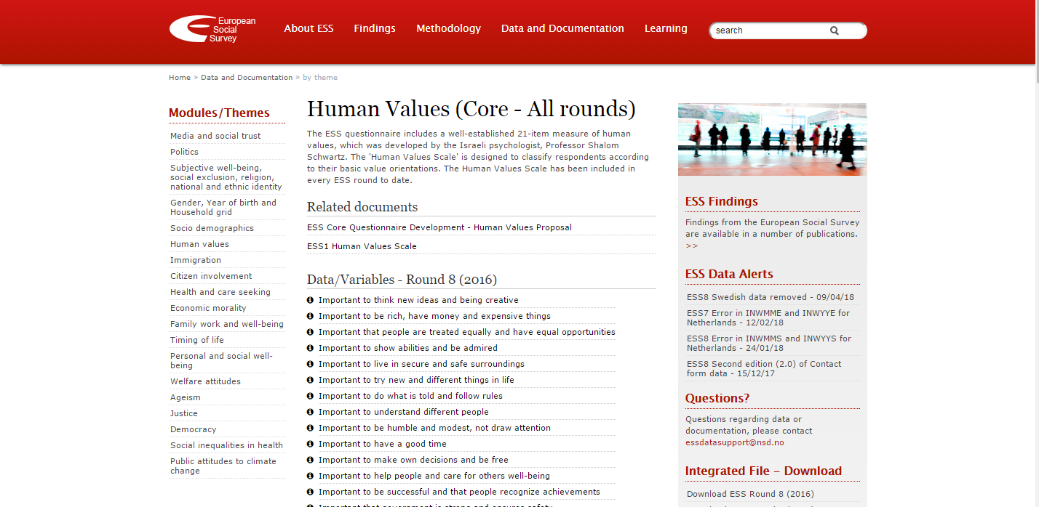

Other ways to access ESS Data Download Wizard
- Returning back to Data and Documentation section, you can find details of other ways of accessing ESS data.

Cumulative Data (Wizard)
You can generate and download a customised subset of the ESS cumulative file by selecting rounds, countries and variables. The ESS Data Download Wizard gives access to cumulative data from countries that have been included in the integrated ESS files in two or more rounds, and all variables from questions that have been asked in more than one round. The data file can be downloaded in SPSS, Stata, and CSV format. A Study Description and documentation of the selected variables is generated for each customised data file and is included in the download.

Multilevel Data (MD) and MULTILEVEL DOWNLOAD
The ESS MD contains data on individuals, regions and countries. Its purpose is to facilitate the task of adding data on countries and regions to the ESS survey data. You can browse the data online or use the multilevel download to create a dataset with information about countries and regions (4 different levels) linked to ESS respondents. The download will include documentation for the selected variables.

ONLINE
The ESS can be explored and examined online using the NESSTAR system. The ESS learning pages ESS EduNet include useful guides to using NESSTAR.

Further resources

- Data Skills Modules from the UK Data Survey
https://www.ukdataservice.ac.uk/use-data/data-skills-modules
Introductory level interactive modules designed for users who want to get to grips with keys aspects of survey, longitudinal and aggregate data.

- NSD Macro Data Guide
http://www.nsd.uib.no/macrodataguide/index.html
From the NSD (the Norwegian data Service), the Macro Data Guide provides links to and information about a wide range of both aggregate and system-level macro data sources.

- European Social Survey Multilevel data
http://www.europeansocialsurvey.org/data/multilevel/guide/about.html
The ESS Multilevel Data aims to make it easier for the research community to analyse the ESS-respondents with reference to the context they live in. The resource contains data about individuals (the ESS respondents), regions (mainly data collected from EUROSTAT) and countries (data collected from different sources). It provides insight into a range of macro-data sources.

- CIMES (Centralising and Integrating Metadata from European Statistics)
https://cimes.casd.eu/
CIMES provides a large and comprehensive overview of official microdata disseminated for research purposes by the national statistical institutes (NSI) across Europe.

- UK Data Service guide on reusing qualitative data (with suggested further reading)
https://www.ukdataservice.ac.uk/use-data/guides/methods-software/qualitative-reuse

- Book on Data Resources for the Study of Politics in the Czech Republic by P. Lyons
http://www.soc.cas.cz/en/publication/theory-data-and-analysis-data-resources-study-politics-czech-republic

- Guides from the UK Data Service (all access via UK Data Service website)
The R guide to UK Data Service key UK surveys: http://ukdataservice.ac.uk/media/398726/usingr.pdf
What is SPSS 20 for Windows? http://ukdataservice.ac.uk/media/342808/usingspssforwindows.pdf
What is Stata?: http://ukdataservice.ac.uk/media/359156/whatisstata.pdf
What is weighting: https://www.ukdataservice.ac.uk/media/285227/weighting_2_1.pdf
What is complex survey design:
https://www.ukdataservice.ac.uk/media/398743/complexsampleguide_1_2.pdf
What are hierarchical files: http://ukdataservice.ac.uk/media/277533/whatareHierarchicalFiles.pdf
Using survey data guide: https://www.ukdataservice.ac.uk/media/455510/using-survey-data.pdf

- ESS EduNet
A training resource from the European Social Survey that covers issues of theory, data and methodology in social science across several research themes. Hands-on exercises offer practical instruction, including the interpretation of statistical results.
Access via the ESS website or http://essedunet.nsd.uib.no/

